A

**PROJECT REPORT**

ON

JAMALI-COLLECTION (E-COMMERCE SITE)

**SUBMITTED BY**

DAUDIBOHRA MUFADDAL MOHAMMAD BHAI

(261)

UNIVERSITY OF PUNE

**BACHELOR OF BUSINESS ADMINISTRATION**

**(COMPUTER APPLICATION)**

ABEDA INAMDAR SENIOR COLLEGE

PUNE – 41101

**UNDER THE GUIDANCE OF**

MRS. ALIFIYA JAHAGIRDAR

MRS. ASHWINI THOPTE

**IN THE ACADEMIC YEAR**

2020-2021

# INDEX

|  |  |  |
| --- | --- | --- |
| **SR. NO** | **Topics** | **Page No** |
| **1.** | **Acknowledgement** | ***4*** |
| **2.** | **Introduction** | ***4*** |
| **3.** | **Project Description** | ***5*** |
|  | Existing System & Proposed System |  |
|  | Jamali-Collection features |  |
| **4.** | **Scope of the System** | ***7*** |
| **5.** | **System Design** | ***7*** |
|  | 1. **Logical & Physical** |  |
|  | 1. **E-R Diagram** |  |
|  | 1. **DFD Diagram** |  |
| **6.** | **Data Dictionary** | ***9*** |
| **7.** | **Software Used In This Project** | ***12*** |
| **8.** |  | ***13*** |
| **9.** |  | ***15*** |
| **10.** | **Page Preview** | ***16*** |
| **11.** | **Conclusion** | ***22*** |
| **12.** | **Future Enhancement** | ***23*** |
| **13.** | **Limitations** | ***23*** |
| **14.** | **Biography** | ***24*** |

* **ACKNOWLEDGEMENT**

I wish to thank various people for their contribution to this project; Mrs. ***Alifya J.*** , and Mrs.Ashwini T. for their valuable technical support on this project.

* **INTRODUCTION**

**I**ndia has often been called a nation of shopkeepers. Presumably there reason for this is that a large number of retail enterprises exist in India.

This project is a web based shopping system for an existing shop. The project objective is to deliver the online shopping application into website platform.

Online shopping is the process whereby consumers directly buy goods or services from a seller in real-time, without an intermediary service, over the Internet. It is a form of electronic commerce. This project is an attempt to provide the advantages of online shopping to customers of a real shop. It helps buying the products in the shop anywhere through internet by using an internet. Thus the customer will get the service of online shopping and home delivery from his favorite shop

## Project Description

## The central concept of the application is to allow the customer to shop virtually using the Internet and allow customers to buy the items of their desire from the store. The information pertaining to the products are stores on an NON-RDBMS at the server side (store).

## The Server process the customers and the items are shipped to the address submitted by them. The application was designed into one modules first is for the customers who wish to buy the articles. The end user of this product is a departmental store where the application is hosted on the web and the administrator maintains the database. The application which is deployed at the customer database, the details of the items are brought forward from the database for the customer view based on the selection through the menu and the database of all the products are updated at the end of each transaction. Data entry into the application can be done through various screens designed for various levels of users. Once the authorized personnel feed the relevant data into the system, several reports could be generated as per the security.

### Existing System:-

The current system for shopping is to visit the shop manually and from the available product choose the item customer want and buying the item by payment of the price of the item .

1. It is less user-friendly.
2. User must go to shop and select products.
3. It is difficult to identify the required product.
4. Description of the product limited.
5. It is a time consuming process
6. Not in reach of distant users.

### Proposed System:-

In the proposed system customer need not go to the shop for buying the products. He can order the product he wish to buy through the web application in his Smartphone. The shop owner will be admin of the system. Shop owner can appoint moderators who will help owner in managing the customers and product orders. The system also recommends a home delivery system for the purchased products.

### Jamali – Collection (E-Commerce Site) features:-

1. You can add item or remove item according to your need
2. Many brands at one place
3. Everything is fresh and on date items
4. Cash on Delivery 🚚 to you Home & Office
5. Same as market Prices

### Scope of the System:-

1. This system can be implemented to any shop in the locality or to multinational branded shops having retail outlet chains. The system recommends a facility to accept the orders 24*7 and a home delivery system which can make customers happy.
2. If shops are providing an online portal where their customers can enjoy easy shopping from anywhere, the shops won’t be losing any more customers to the trending online shops such as flipkart or ebay. Since the application is available in the Smartphone it is easily accessible and always available.

### SYSTEM DESIGN:-

System design is the solution for the creation of a new system.

This phase focuses on the detailed implementation of the feasible system. It emphasis on translating design. Specifications to performance specification. System design has two phases of development

* Logical design
* Physical design

During logical design phase the analyst describes inputs (sources), output s(destinations), databases (data sores) and procedures (data flows) all in a format that meets the user requirements. The analyst also specifies the needs of the user at a level that virtually determines the information flow in and out of the system and the data resources. Here the logical design is done through data flow diagrams and database design. The physical design is followed by physical design or coding. Physical design produces the working system by defining the design specifications, which specify

exactly what the candidate system must do. The programmers write the necessary programs that accept input from the user, perform necessary processing on accepted data and produce the required report on a hard copy or display it on the screen.

### Data Dictionary:-

**DataBase Tables:**

**Dashboard**

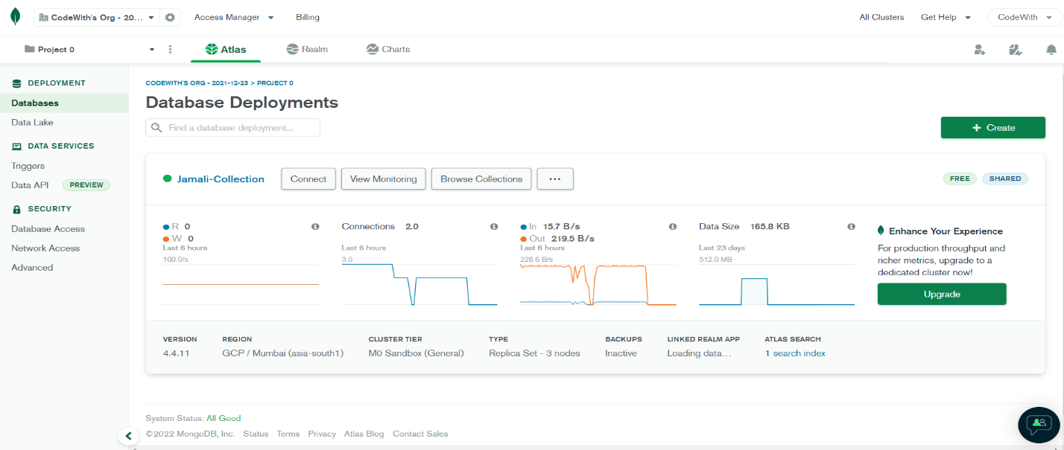

This is a Dashboard Of Jamali-Collection Data base , I have use Mongodb for non sequel database ,

It’s a Cloud Bash database .

#### Users Table

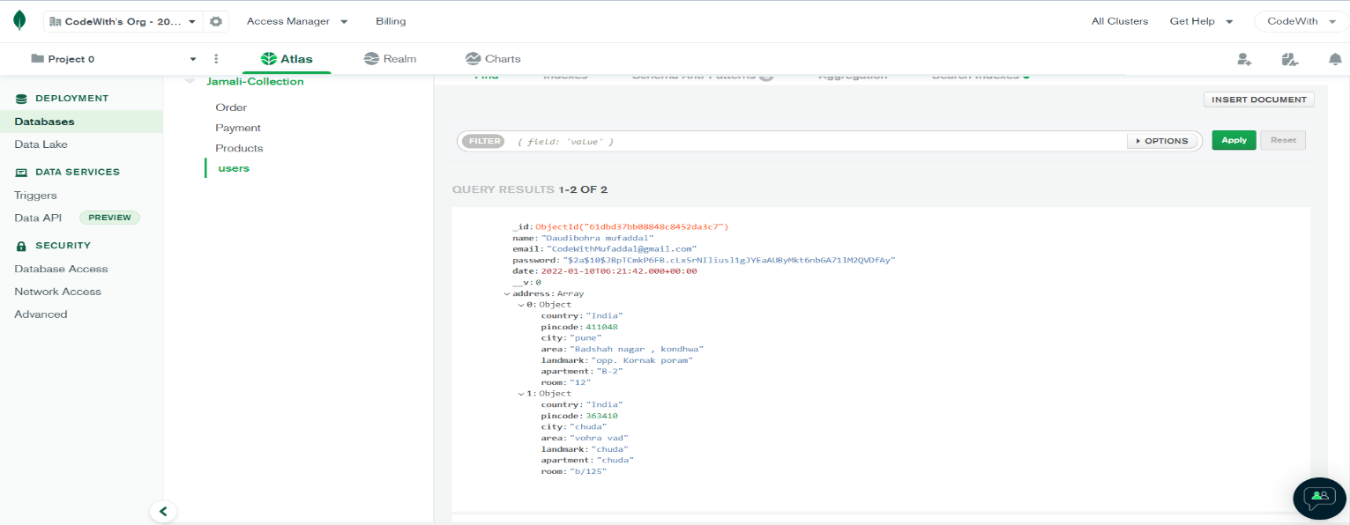

This table stores the data of Admin & users that register on our website. Plus it store the address of user to deliver The Product user can store multiple addresses at a single account.

#### Product Table

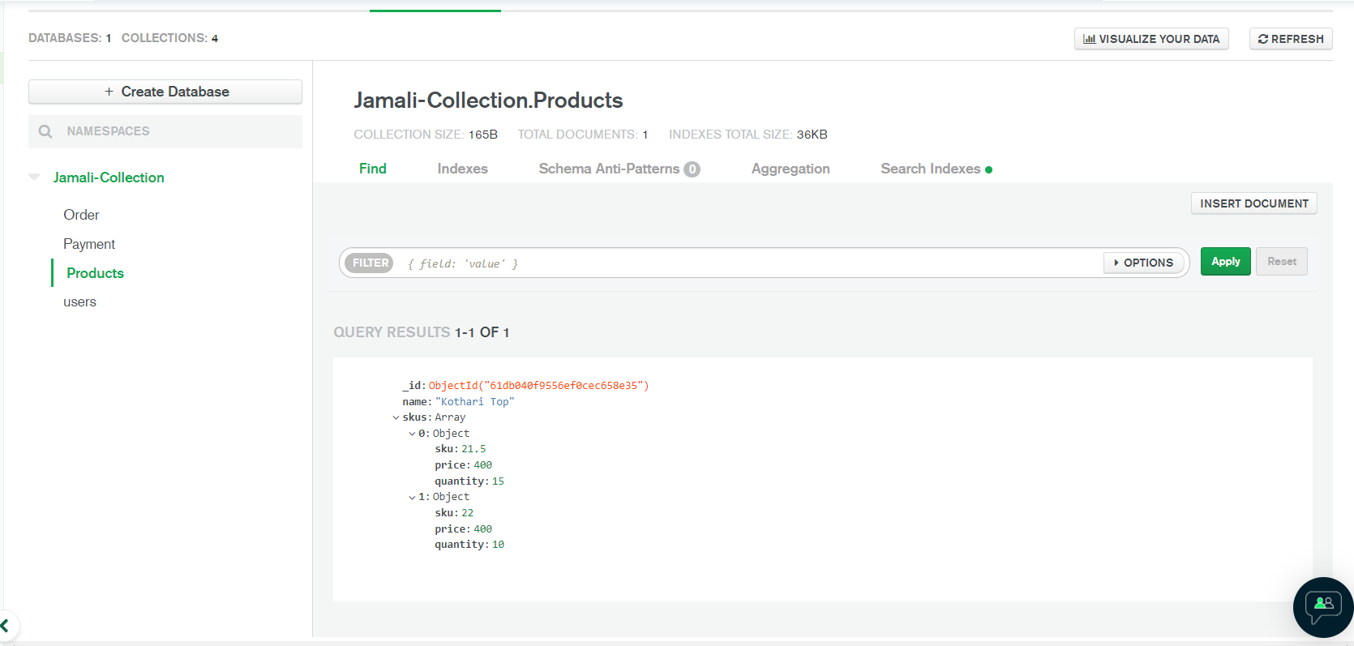

This Table Store SKU’s(Stock Kipping Units) and Product information.

#### Order History Table

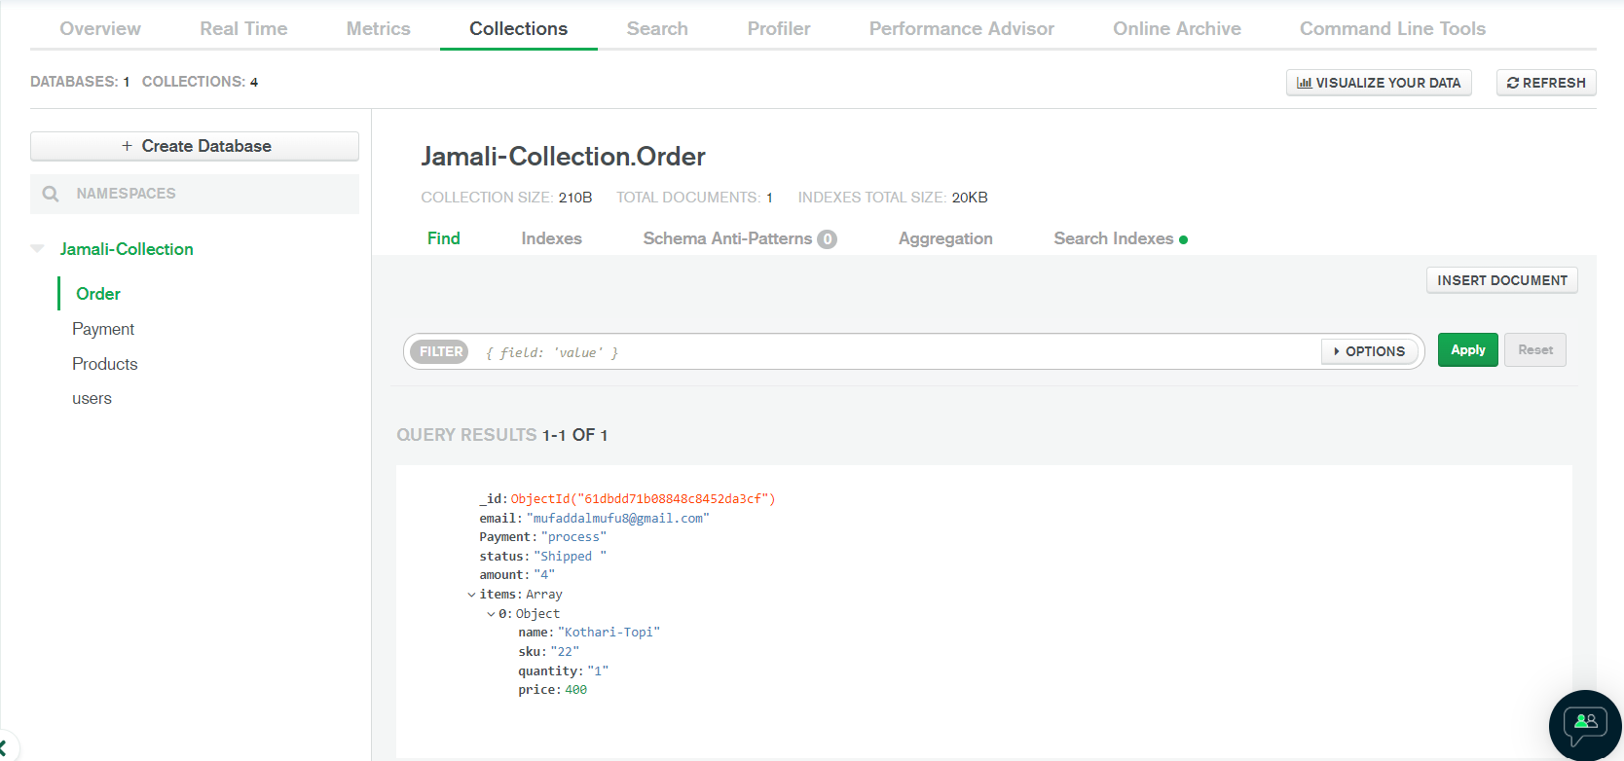

This Table stores The history of users Previous Order’s (Static).

**Payment Table**

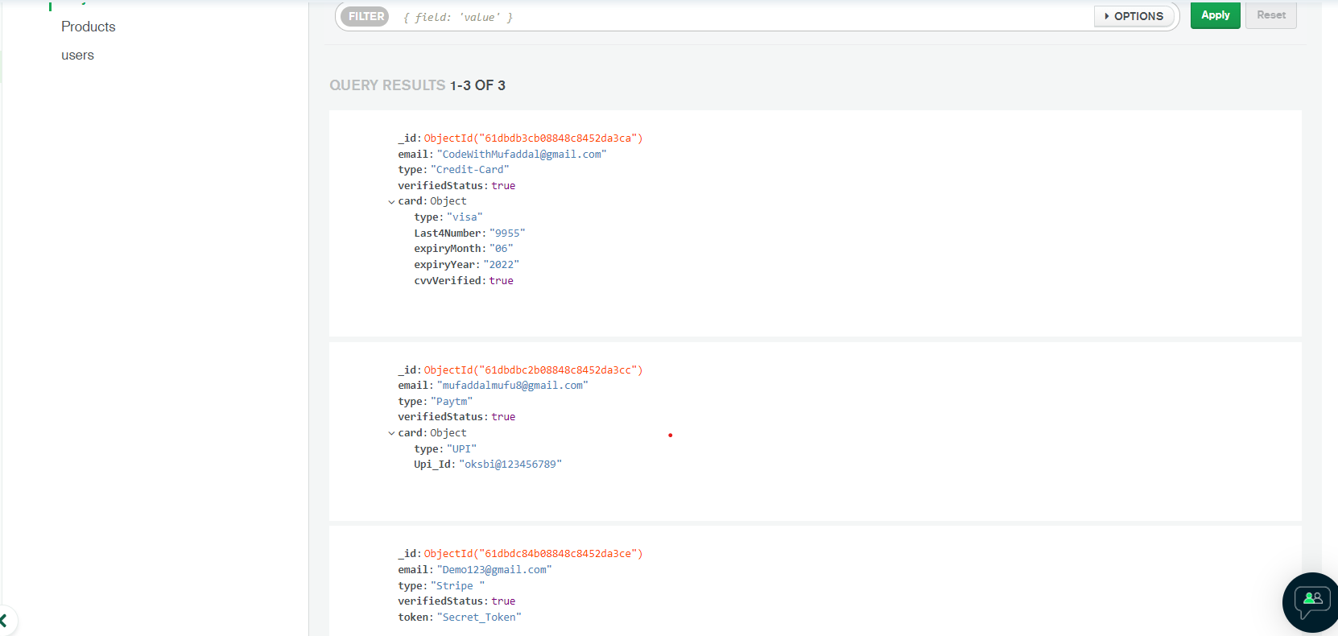

This Table stores Payment details , That must be protected, so we store it in a various different formats like for card we only take last 4 digits & cvv Boolean values, for payment like strip we take token and soo on.

**Address Table**

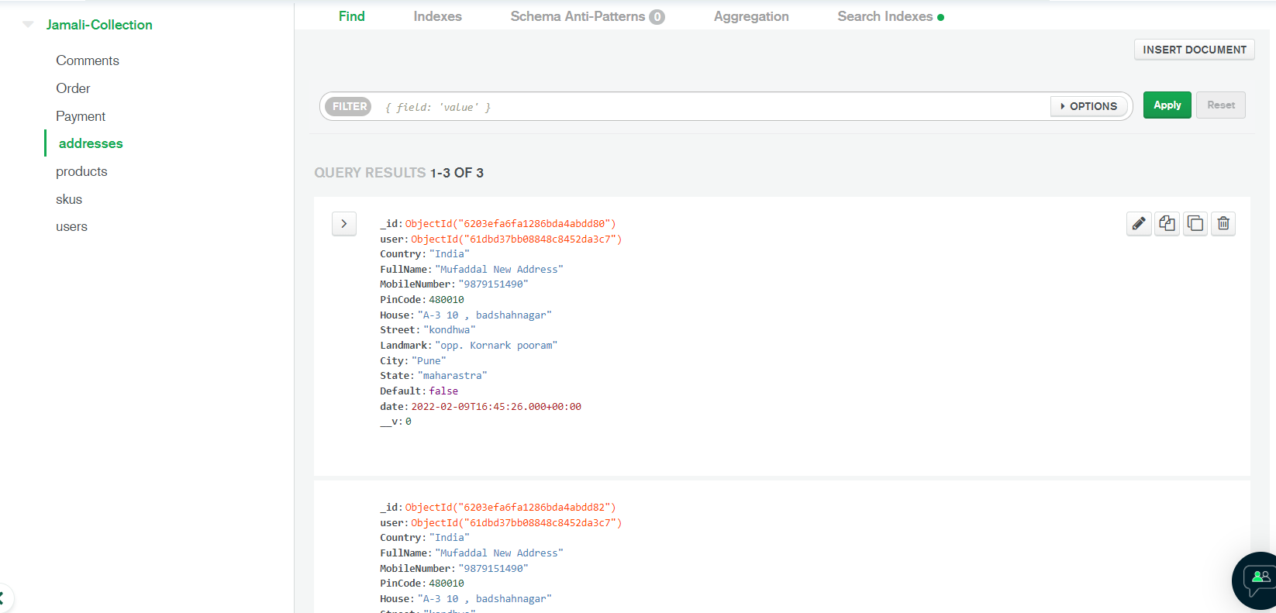

This Table Containe Address Details of login User With there User ids as well as it Perform CRUD opretion on Address

#### Software Used In this PROJECT

Jamali-Collection (E-Commerce Site)

**Front end**: Html ,css , Javascript , React.js

1. HTML: HTML is used in form of JSX that run in react freamwork.
2. CSS : (Cascading Style Sheets) Create attractive Layout
3. React: to create Single page application with 0 loading Time

**Other FE libraries** :

React Hooks,

Bootstrap

Material Ui (icons)

React Router Dom

**Back end**: MongoDB , Node.js , Express.js

1. MongoDB: Mongo db is a database to store the data ,

What makes special mongodb is you don’t have to follow schema to store the data that’s why we choose mongo for this project | also I use Cloud base database that can use by anywhere and work anytime

1. Node.js: Node.js is allow us to use JavaScript in server site as a beckend Language
2. ● Express.js: to route the backend server seamlessly

**Other BE libraries** :

Mongoose

Express Validatore

Own Api Keys

**Hosting: Firebase** for Front end && **Heroku** for Backend

1. Firebase: firebase is powered by Google that provide free basic Hosting , data storage, authentication, etc…
2. Heroku is used as storing my BE data on a VPS (virtual Private server)

#### E-R DIAGRAMS

**Login:**

Login Details

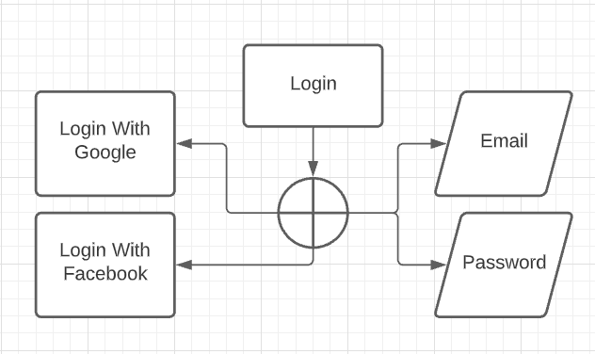

* **Register Detail**

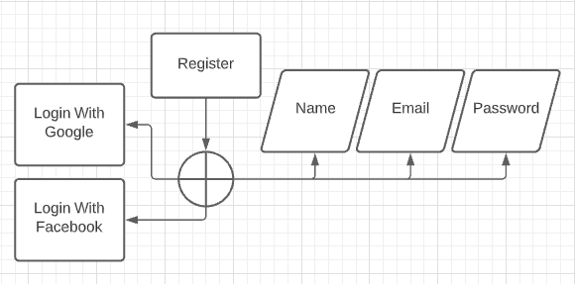

Register DETAILS

* 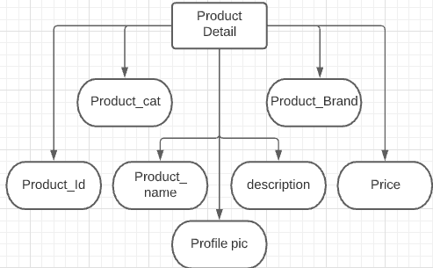**PRODUCT DETAILS**

Product Details

#### DATA FLOW DIAGRAM

* LOGIN 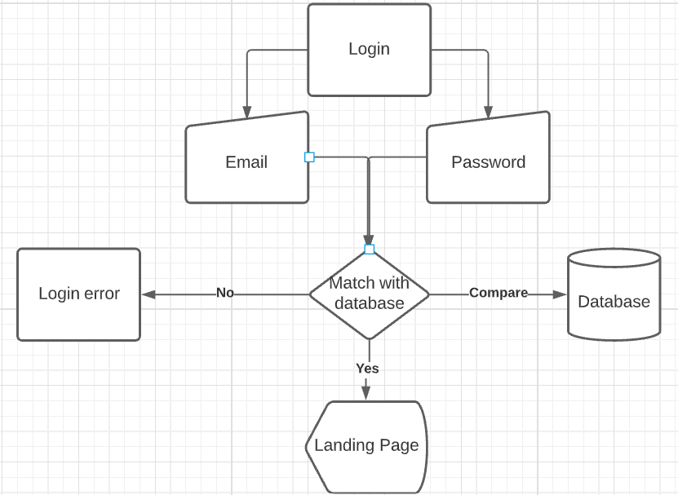

Login DFD

* REGISTRATION DFD

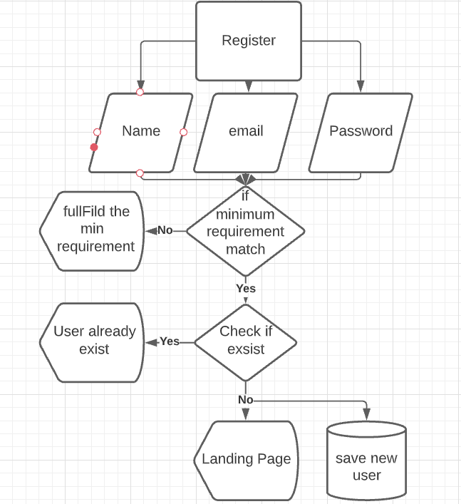

**Page Preview**

**LOGIN - PAGE**

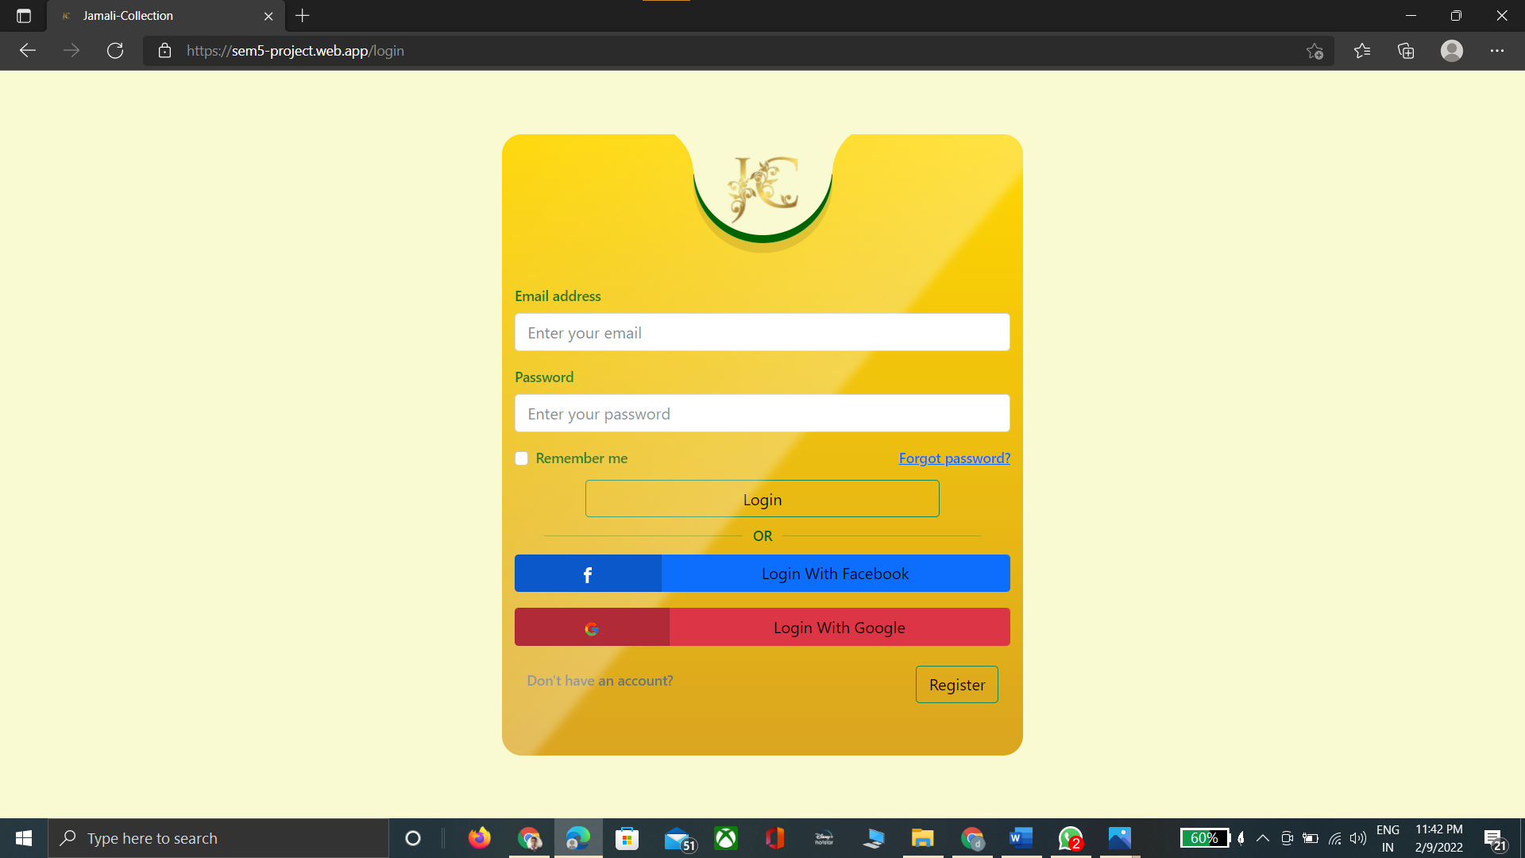

**REGISTRATION - PAGE**

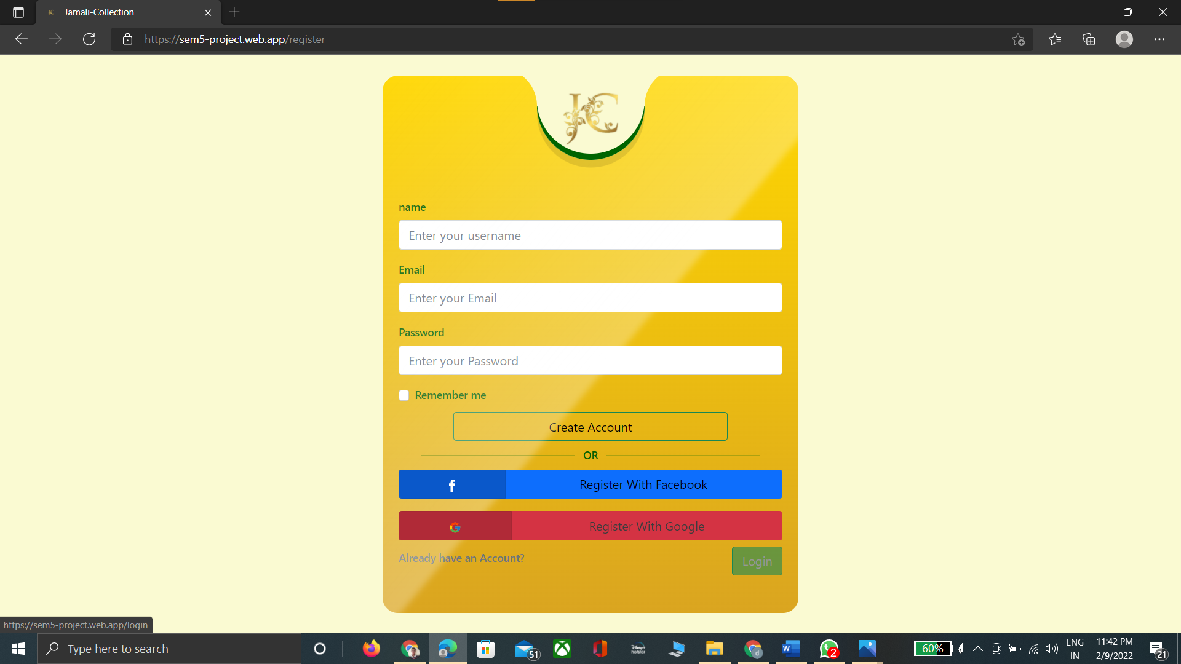

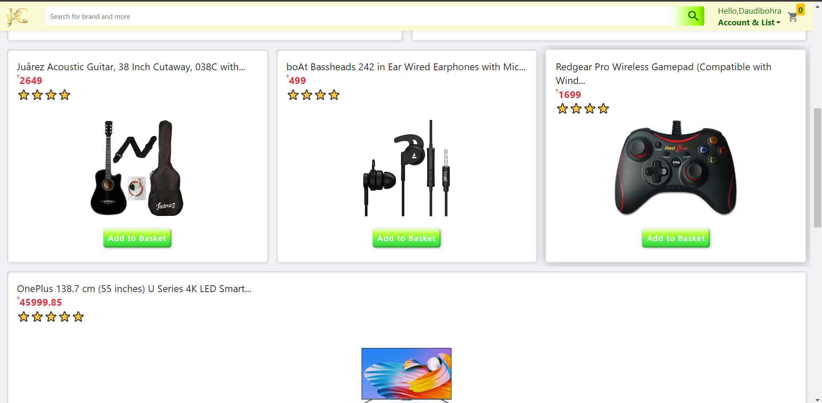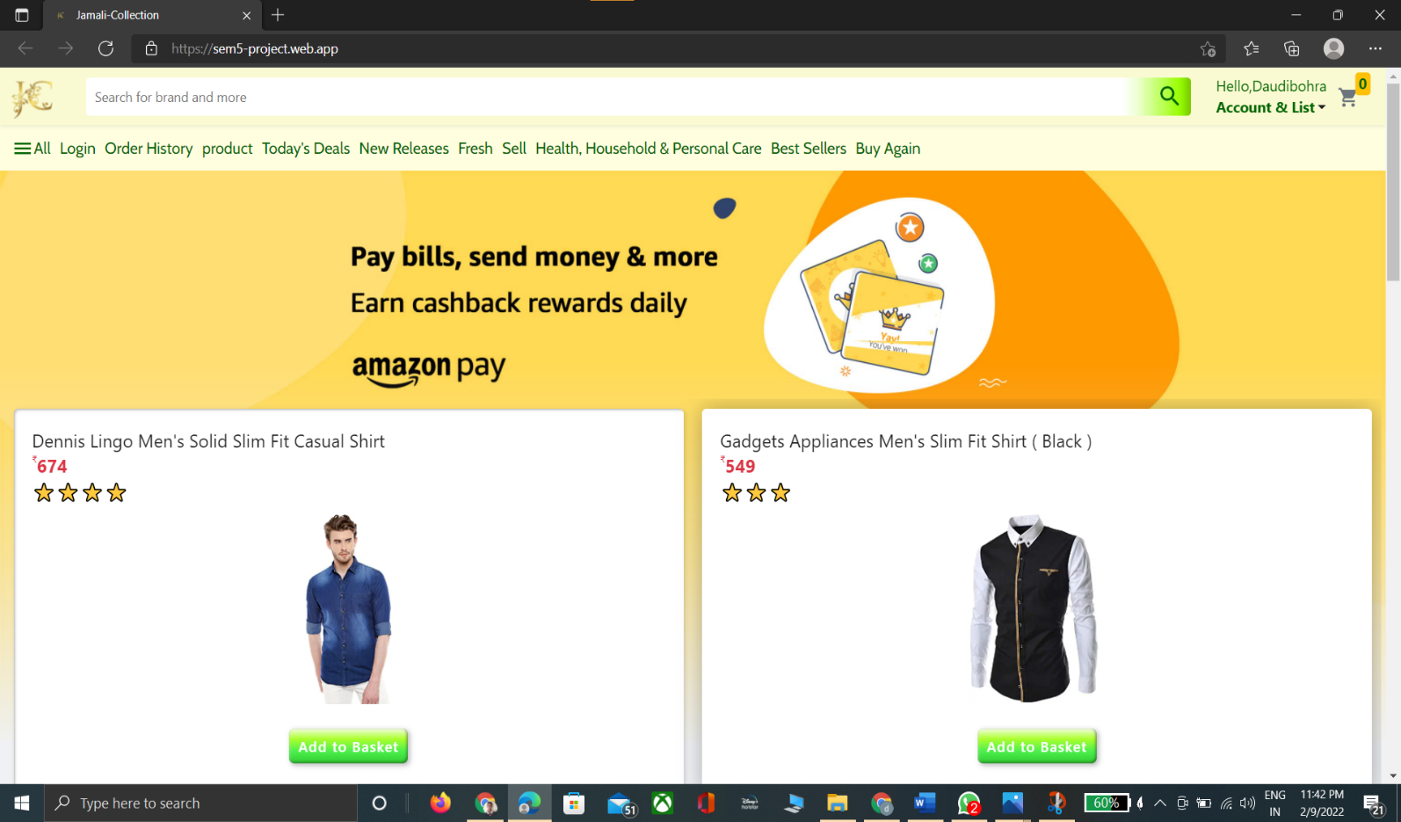**HOME - PAGE**

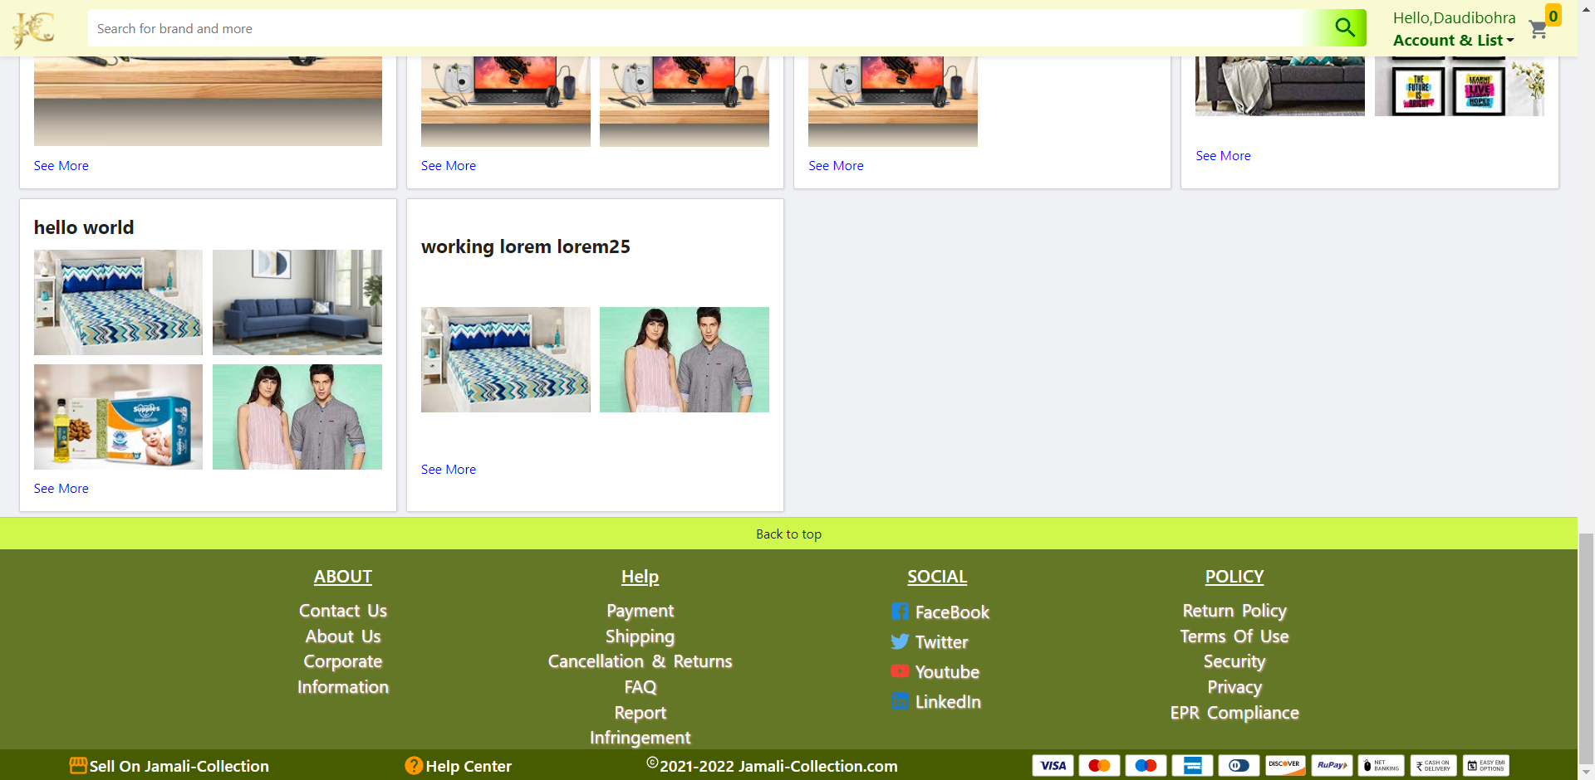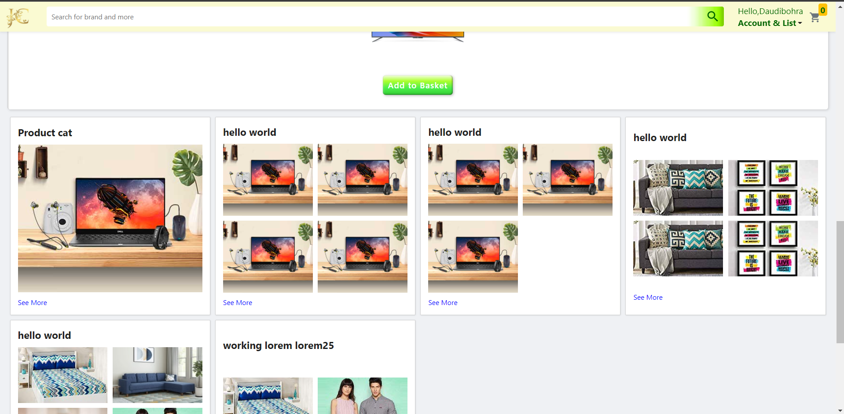

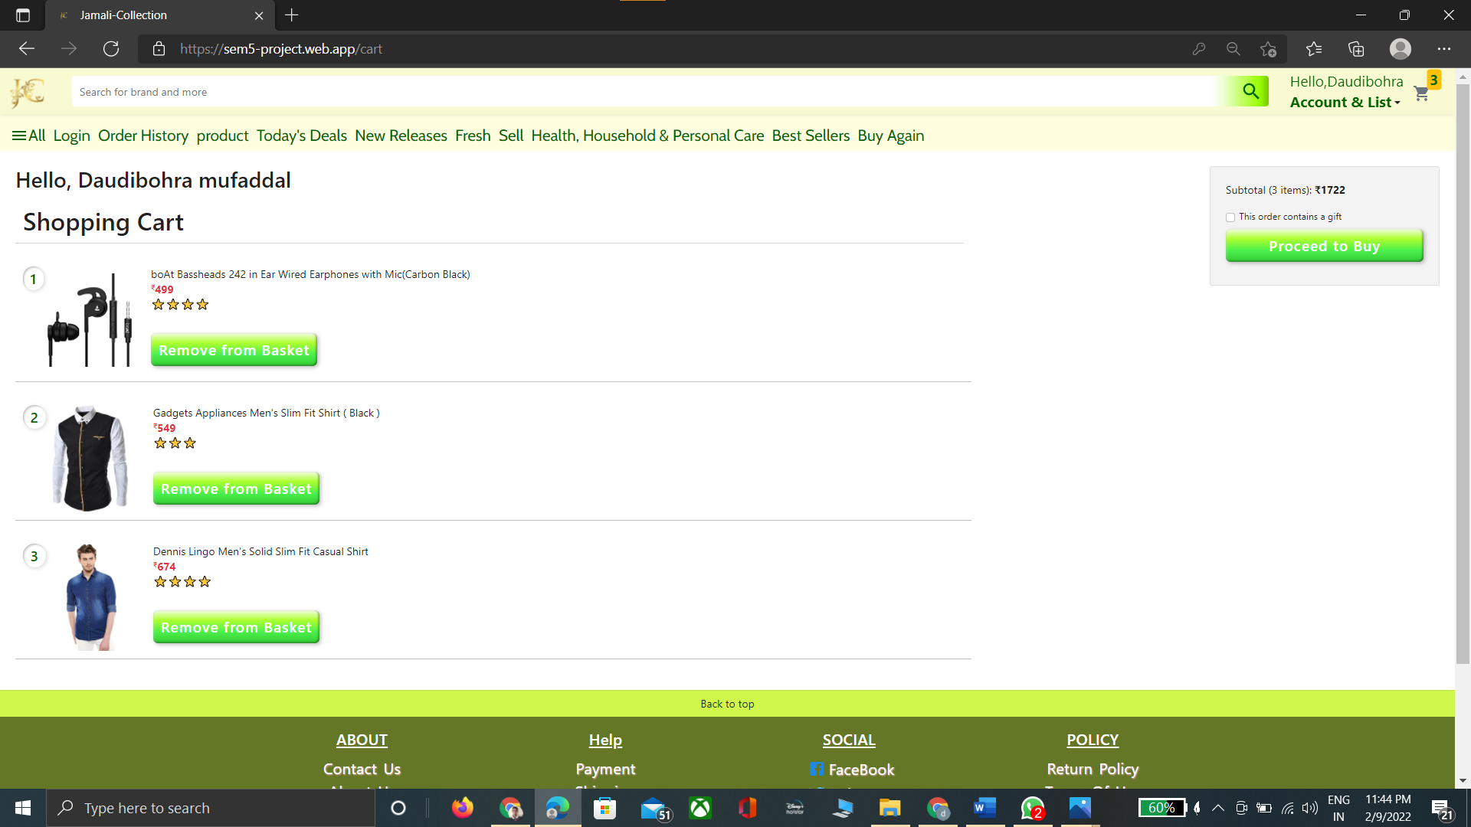**Cart- PAGE**

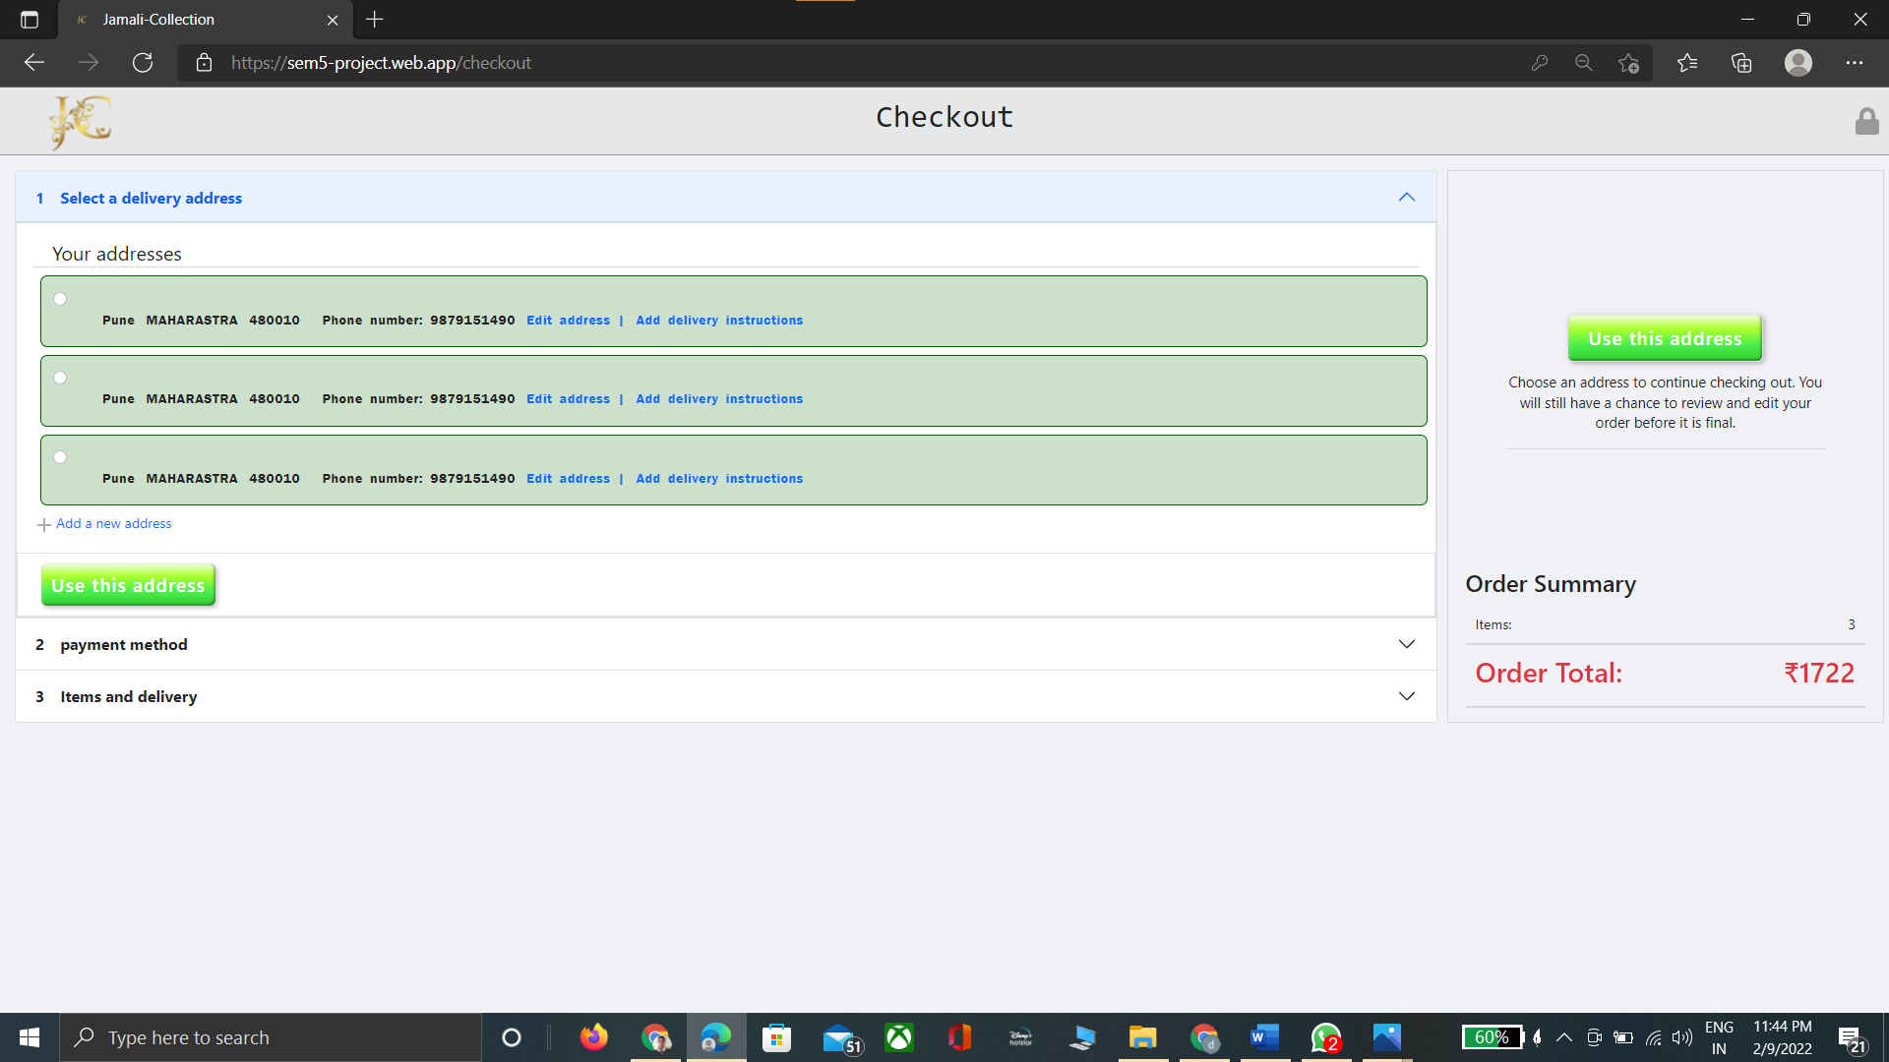**Checkout- PAGE**

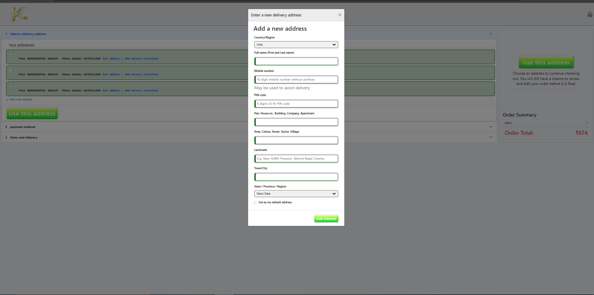**Add new Address - Modal**

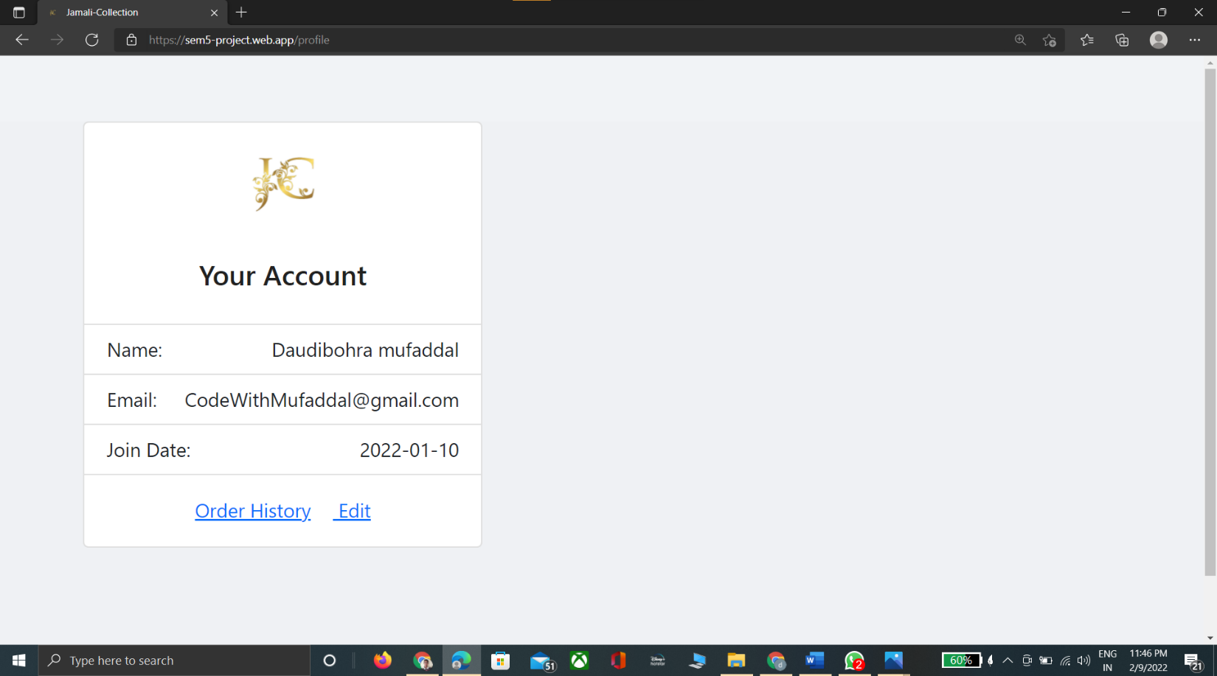**User Profile – PAGE**

#### Conclusion:-

The project entitled **Jamali - Collection** was completed successfully.

The purpose of this project was to develop a web application for purchasing items from a shop.

This project helped us in gaining valuable information and practical knowledge on several topics like designing web pages using html & css, Javascript ,react and management of database using mongodb and server site rendering via node.js , express.js .

Also the project helped us understanding about the development phases of a project and software development life cycle. We learned how to test different features of a project.

This project has given us great satisfaction in having designed an web application can be implemented to any nearby shops or branded shops selling various kinds of products by simple modifications.

There is a scope for further development in our project to a great extend. A number of features can be added to this system in future like we wished to implement was providing classes for customers so that different offers can be given to each class. System may keep track of history of purchases of each customer and provide suggestions based on their history. Implement the algoria api for search algorithm These features could have implemented unless the time did not limited us.

### Future Enhancement:-

This project has given us great satisfaction in having designed an web application can be implemented to any nearby shops or branded shops selling various kinds of products by simple modifications. Also we adding moderator part.

There is a scope for further development in our project to a great extend. A number of features can be added to this system in future like we wished to implement was providing classes for customers so that different offers can be given to each class. System may keep track of history of purchases of each customer and provide suggestions based on their history. These features could have implemented unless the time did not limited us.

We also wanted to add features like Payments, algoria for search , many more things. Etc….

#### Limitations:-

1. Delay in delivery.
2. Lack of significant discounts in online shops.
3. Lack of touch and feel of merchandise in online shopping.
4. Lack of interactivity in online shopping.
5. Lack of shopping experience.
6. Frauds in online shopping.

#### Biography:-

#### Youtube:

**Code with harry**

**Clever Programmer**

**Free code camp**

#### WebSite:

www.Javascript.net [www.w3schools.com](http://www.w3schools.com)

[www.mongodb.com](http://www.mongodb.com)

[www.mongoose.com](http://www.mongoose.com)